**Project Name:** *StandStage*

**Abstract** **2**

Project Background **2**

**Business Objectives and Scope** **3**

Business Objectives 3

Scope 3

*Example functions* *3*

**Proposed Solution Technical Components** **3**

Smartphone Application & Website 3

Online Database 4

Technical Feasibility 4

Organizational Feasibility 4

Risk and Constraints 4

*No user* *4*

*Repeatability* *4*

*Development problem* *5*

**Use Case Diagram (in 1 diagram )** **5**

**Use Case Descriptions** **6**

**Conceptual Class Diagram** **14**

**Design Class Diagram** **15**

Description of the Class Diagram 16

**Sequence Diagram** **17**

**Search:** **17**

**Old:** **17**

**New:** **17**

**Promotion Post** **18**

Promotion post (old) 18

Promotion post (new) 19

**Principles** **20**

**Project Management** **20**

**Management Model** **21**

**Risk Management** **21**

**The validity of involved parties** **22**

**Uniqueness of our platform** **22**

**Security concerns** **22**

**Functionality of web page** **23**

**Conclusion** **23**

**Website UI Design** **24**

## Abstract

Standstage is an online platform that aims to provide an easy and straightforward solution for the different needs of stand-up performances.

The platform is designed to provide adequate functions for different users such as the performers, audiences, sponsors, advertisers, and organizers to suit their needs.

## Project Background

We are living in an era of growing talents, anyone can be a star of their own if given the right platform and exposure.

There are more traditional social media platforms such as Facebook, Twitter, Instagram and Youtube where thousands and millions of people rose to fame and became social influencers. And there are also newer platforms such as TikTok, which users get at most 60 seconds per video to display their talents and probably catch your attention.

We are aware that there are already a whole variety of platforms available but what we notice is, quantity does not justify the quality. Finding quality content on the above platform can be a big challenge cause there is no entry barrier to post on those platforms, therefore, finding suitable collaborators for professional collaborations is like finding a needle in a haystack.

This is why on our platform, we would like to focus on providing opportunities for professional collaborations which there will be a certain entry barrier for users on our platform. We will have official reviews on different parties on our platform to maintain the quality of each as we hope that the professionalism of our service can differentiate us from ordinary social media platforms.

## Business Objectives and Scope

### Business Objectives

To enhance the efficiency and easiness of organizing a stand-up live show through the usage of an online platform.

### Scope

We aim to build a platform that could streamline the process of organizing a stand-up show by providing different useful functions to different users.

For show organizers, they can use the platform to find performers, coworkers, sponsors and to get everything ready online.

For performers, they can use the platform to promote themselves to find more opportunities.

For sponsors and advertisers, they can use the platform to find the shows that suit their requirements or to find organizers and performers that have the experience.

#### 

#### *Example functions*

1. Users can organize a stand-up live show online through the platform
2. Performers can promote themselves to sponsors and advertisers.
3. Sponsors and advertisers can request specific shows to participate in.
4. Organizers or performers can find coworkers and work on a show together.
5. Organizers can promote their shows through the platform.
6. Performers and organizers can set up their own profiles to display their past works (to promote themselves or to attract potential sponsors)
7. Organizers can contact the sponsors or advertisers directly.
8. Provide a professional platform to the user to find the performers/Collaborators.
9. Users can search the user/performance through the keywords.

## Proposed Solution Technical Components

We will have a website, IOS application, and android application in this project, all functions will be included and share the same database.

### Smartphone Application & Website

For the Smartphone Application and website we focus on:

1. Smart, smooth, and clear UI interface.
2. Users can organize a stand-up live show online on both platform
3. To connect the database between the website and the Smartphone Application. Update the user information and behavior synchronously.
4. Setting a matching system between the user.

The user interface was not designed yet, but we want to give a smart and clear feeling when the user is using our platform and reduce unnecessary loading or interface to reduce the user’s Irritability.

All user’s information/ their action when they use our platform will be recorded synchronously, like organizing a stand-up live show, watching the show ..etc.

### Online Database

This is the place where all the data about all the users. It includes User Name, User ID, Photograph, Status( Performers, Sponsors or advertisers, and Audience.), Live show, etc…

Every user can check the other user’s information when the user publishes their information.

### Technical Feasibility

About the technical feasibility, the project is going to create a platform for users who are interested in or related to stand-up performances, such as performers, sponsors, and other coworkers. The platform would be available in two forms, which are smartphone applications and websites. According to this situation, as both platforms are commonly used by the public, the technologies and infrastructures which are needed for the project are already excess.

### Organizational Feasibility

Since the target audiences are stand-up performance performers, potential performers and potential sponsors, and other related coworkers, we are confident that they will be welcoming to this project, as the project will become a platform that is professional, accessible, and helpful. Because our potential users are spread out a lot, the project can become a bridge that leads them to each other and connects them.

### Risk and Constraints

#### No user

During the earlier stages, the platform might only attract a very small number of users to use the services provided.

Or the platform might lose its users slowly to the point where there are not enough users to support the platform.

But this problem could be partially eased by promoting the platform on different media and/or by inviting renowned performers and organizers to try and use the platform, as this may increase the reputation and popularity of the platform.

#### Repeatability

What we do might end up being redundant to other social media platforms and there may be no reason for users to switch to our platform.

This can be a problem if we fail to give users enough incentive to switch to our platform; this is why we should have a clear positioning in the market. As most social media platforms focus on providing entertainment, we should instead focus on business. This is how we can potentially differentiate our application from the other existing platforms.

#### Development problem

We might experience different problems during the development.

For example, there might be problems with the synchronization of data between different platforms (as we have web, IOS, and android versions) or we might experience technical difficulties such as overwhelming server pressure.

We can ease this problem by arranging tests and quality assurance beforehand to help detect and improve the potential bugs and problems of the platform, for example, we can arrange multi-platform tests during the different stages of development or do a stress tests on the servers before launching a major update.

## Use Case Diagram (in 1 diagram )

# 

### 

### 

### 

### 

## Use Case Descriptions

**StandStage**

|  |  |  |  |
| --- | --- | --- | --- |
| Author Name : |  | Date : | 02/03/2021 |

|  |  |  |
| --- | --- | --- |
| Use Case ID : | SStg-UC001 | |
| Use Case Name : | Organizing a stand-up live show | |
| Actor(s) : | Primary : Organizers Secondary : Performers | |
| Description : | This use case describes the scenario of a system user (an organizer or a performer) wishes to create a stand-up live show on the system. The user will input details that are required while the system validates the inputted detail. After validation, the show is created and the profile of the related user is updated. | |
| Priority : | High | |
| Preconditions : | The system user is authorized to set-up a live show online. | |
| Trigger : | Users choose to set up a new live show while being authorized to do so. The system starts the creation process. | |
| Typical Course Of Events : | Actor Action | System Response |
|  | 1. User creates a new live show. | 2. System asks for basic information |
|  | 3. User enters information required | 4. System save the information into a draft |
|  | Repeat step 3, 4 till all necessary information is filled.  5. User confirms the basic information is correct. | 6. System asks for show type |
|  | 7. User selects the type of the show |  |
|  |  | 8. System save into draft and asks for show details |
|  | 9.User enters show details |  |
|  | 13. user ends the process. | 10. System compare the show details to check for errors.  Repeat till all details are checked.  11. System logs the draft as a legitimate show.  12.System displays the details of the show. |
| Alternate Courses : | N/A | |
| Postcondition or Results : | The show details are saved, user profiles for all involved is updated. | |
| Exceptions : | exc. 10a: the system detects error and rejects the entered details, go to step 7. | |
| Business Rules : | BR01 only administrators or the creator of the show can modify the details of the show. | |
| Special Requirement : | N/A | |
| Assumptions : | The system database is connected and ready. | |
| Notes and Issues : | 1. basic information: information about the organizer / the organizing organization.  2. show details: the name, time, description and category of the show. | |

**StandStage**

|  |  |  |  |
| --- | --- | --- | --- |
| Author Name : |  | Date : | 02/03/2021 |

|  |  |  |
| --- | --- | --- |
| Use Case ID : | SStg-UC002 | |
| Use Case Name : | Search for user | |
| Actor(s) : | Primary : System user Secondary : | |
| Description : | This use case describes the scenario of a system user using the system to search for another user’s profile.  The user will input keywords while the system will search the database entry for similar results. After the search, the system will display the relevant results(if any). | |
| Priority : | Medium | |
| Preconditions : | The system user can contact another system user regarding a listed project | |
| Trigger : | User looking for suitable projects to join or suitable existing users to collaborate | |
| Typical Course Of Events : | Actor Action | System Response |
|  | 1. User type in keyword(s) in the search bar and type enter | 2. System receive the keywords and filter for relevant profiles from the database  3. System display search results |
|  | 4.User can scroll and review information displayed. If unsatisfied,user can go back to action (1)  5. If user find suitable result, user can click on the profile | 6. The system will display user profile and related information |
|  | 7. User can review listed information on the profile  8. User can choose to send private message to the user profile  10. User can also request to join a project listed on a user profile | 9. The system will receive the message once it’s sent and deliver it to the receiver  10. The system will receive the request and notify the receiver about it  11. If the receiver approve the request, the sender will be listed as part of a project  12. If the receiver respond to the message, the sender will receive the message in the chat box |
|  |  |  |
|  |  |  |
|  |  |  |
|  |  |  |
| Alternate Courses : | N/A | |
| Postcondition or Results : | A user can join an existing project if the request is accepted. Two users can communicate through chat. | |
| Exceptions : | If the request is rejected, the user who requested won’t be able to join an existing project.  Not all profiles on the website are publicly displayed. Users might have to request for permission to access more information. | |
| Business Rules : | The profile owner owns all rights to the information displayed on its own profile. | |
| Special Requirement : | N/A | |
| Assumptions : | The system database can store a large amount of profiles. | |
| Notes and Issues : | 1. It may be difficult to produce a user-friendly yet functional chat system  2. It may be difficult to connect users if profile searching is the only way | |

StandStage

|  |  |  |  |
| --- | --- | --- | --- |
| Author Name : | Yeung Yuen Ching, Iris | Date : | 02/03/2021 |

|  |  |  |
| --- | --- | --- |
| Use Case ID : | SStg-UC003 | |
| Use Case Name : | Promoting an existing live show | |
| Actor(s) : | Primary : System user Secondary : | |
| Description : | This use case describes the scenario of a system user wanting to promote an existing stand-up live show. | |
| Priority : | Medium | |
| Preconditions : | Users are allowed to promote their stand-up live show through the system. | |
| Trigger : | Users chose to promote their show in the system. System starts the process. | |
| Typical Course Of Events : | Actor Action | System Response |
|  | 1. Users go to the promote page from the menu. | 2.System receive order.  3.System ask for basic information. |
|  | 4.User enter basic information. | 5.System check the information.  6.System save the information to draft. |
|  | 7.Repeat 4. to 6. until all the necessary basic information is filled in. | 8.System generate a post according to the filled information.  9.Request the user to confirm the post. |
|  | 10.User confirmed the post. | 11. System asks for approval of publishing the post. |
|  | 12.User sure to publish the post. |  |
|  |  | 13.System publish the post. |
|  |  |  |
| Alternate Courses : | N/A | |
| Postcondition or Results : | System publishes the promotion post under the approval. System users can see the promotion post in the system. | |
| Exceptions : | If users do not give approval, the system could not publish the post and the post will remain draft which only can be seen by the user. | |
| Business Rules : | Users own all the materials provided by them. | |
| Special Requirement : | N/A | |
| Assumptions : | Storage is needed to store the draft. | |
| Notes and Issues : | 1.The promotion post may contain words, images, videos and audios. | |

**StandStage**

|  |  |  |  |
| --- | --- | --- | --- |
| Author Name : | Rai Phirens | Date : | 02/03/2021 |

|  |  |  |
| --- | --- | --- |
| Use Case ID : | SStg-UC004 | |
| Use Case Name : | Uploading the demo videos of their talent to the platform | |
| Actor(s) : | Primary : Performers Secondary : Organisers | |
| Description : | This use case description will allow the users who are the performers, to upload their talent to the platform, which can be only visible to the organisers, as this is like one of the barriers of entry to maintain high quality. | |
| Priority : | Medium | |
| Preconditions : | The system user is authorized to upload videos as performers to the database platform for the organisers to see. | |
| Trigger : | Users choose to set up a new live show while being authorized to do so. The system starts the creation process. | |
| Typical Course Of Events : | Actor Action | System Response |
|  | 1. Users list out their talent. | 2. System saves the information and asks for genre type |
|  | 3. User picks one of the genre type | 4. System saves the information, and asks for a demo video file. |
|  | 5. User uploads the demo video file. | 6. System stores it and compiles all of the information gathered and awaits for organisers to see. |
|  | 7. User ends the process while waiting for confirmations. |  |
|  |  | 8. The organisers decide if it is good or not, and give the final say. |
|  | 9.User is notified if they are approved or not. |  |
|  |  |  |
| Alternate Courses : | N/A | |
| Postcondition or Results : | The details of the users are saved, and they will be awaiting results. | |
| Exceptions : | The file format is not in mp4 or mov, or it is over the 1 GB limit. | |
| Business Rules : | The demo videos should not be confidential and do not go to the public. | |
| Special Requirement : | N/A | |
| Assumptions : | The system database is connected and awaiting the organiser to respond. | |
| Notes and Issues : | 1.. user details: genre of the show, demo video | |

## Conceptual Class Diagram

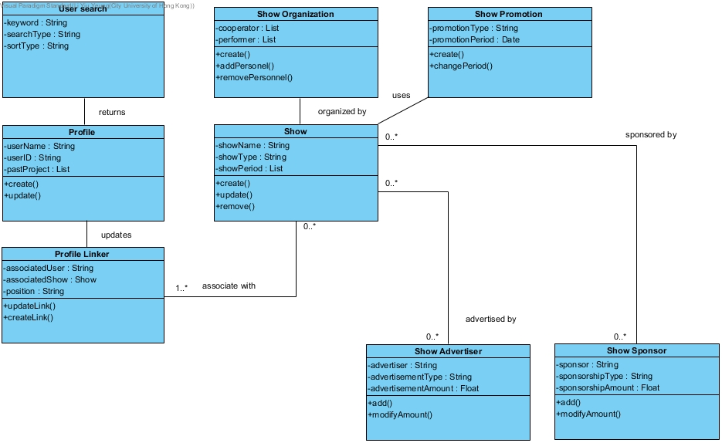

## Design Class Diagram

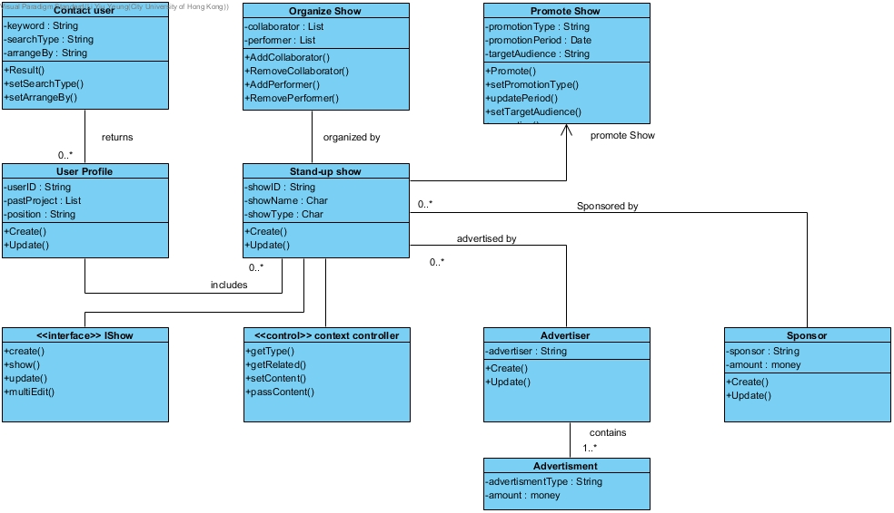

### Description of the Class Diagram

There are eight classes in our design which included Contact User, Organize Show, Promote Show, User Profile, Stand-up Show, Advertiser, Advertisement and Sponsor. Also an interface class IShow and a control class context controller. The Contact User returns User Profile through input keyword then output Result. User Profile included userID, pastProject and position. User Profile is able to be created and updated. Organize Show contains collaborators and AddCollaborator. Stand-up shows included showID, showName, showType which can be created and updated. User Profile includes Stand-up show. Promote Show contains promotionType. Stand-up shows are organized by the Organize Show and can be promoted through Promote Show. Sponsors include sponsor and money amount, allowed to be created and updated. Stand-up show is sponsored by Sponsor and advertised by Advertiser. Advertiser contains Advertisement and Advertisement have advertisementType and money amount.

Users can create and update their user profile, and contact others through their user profile. Stand-up show of the user also shown in the user profile. Users can organize, advertise and promote their show by advertisement and promotion. Users can also sponsor others' shows.

Once a user creates their user profile, userID is created. Data of the user would go under userID, as most functions are linked to Stand-up show and Stand-up show is included in User Profile.

## Sequence Diagram

## Search:

### Old:

### 

### New:

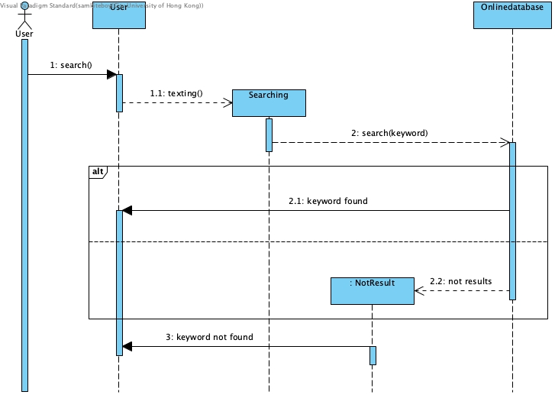

## Promotion Post

We went through a reiteration of a promotional post that is more likely closest to what it should be like.

### Promotion post (old)

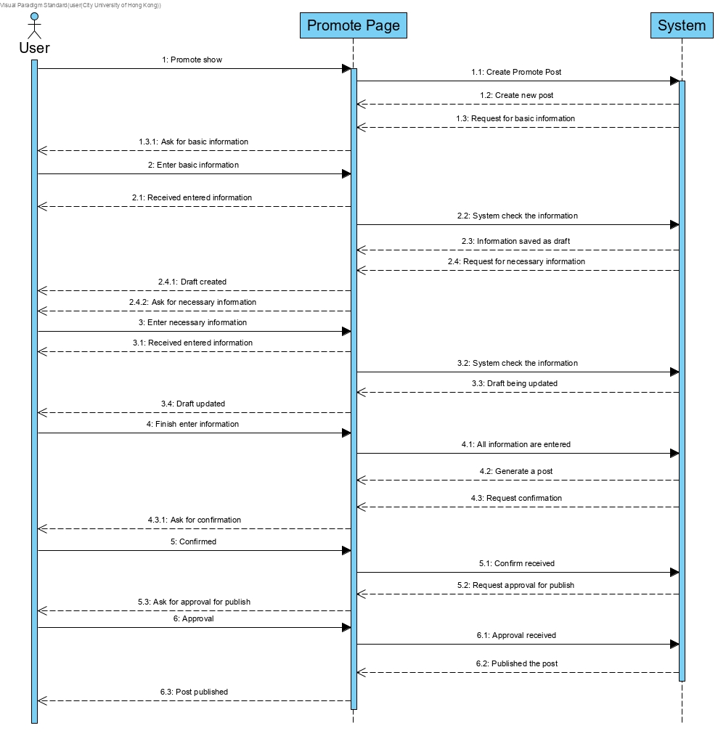

### Promotion post (new)

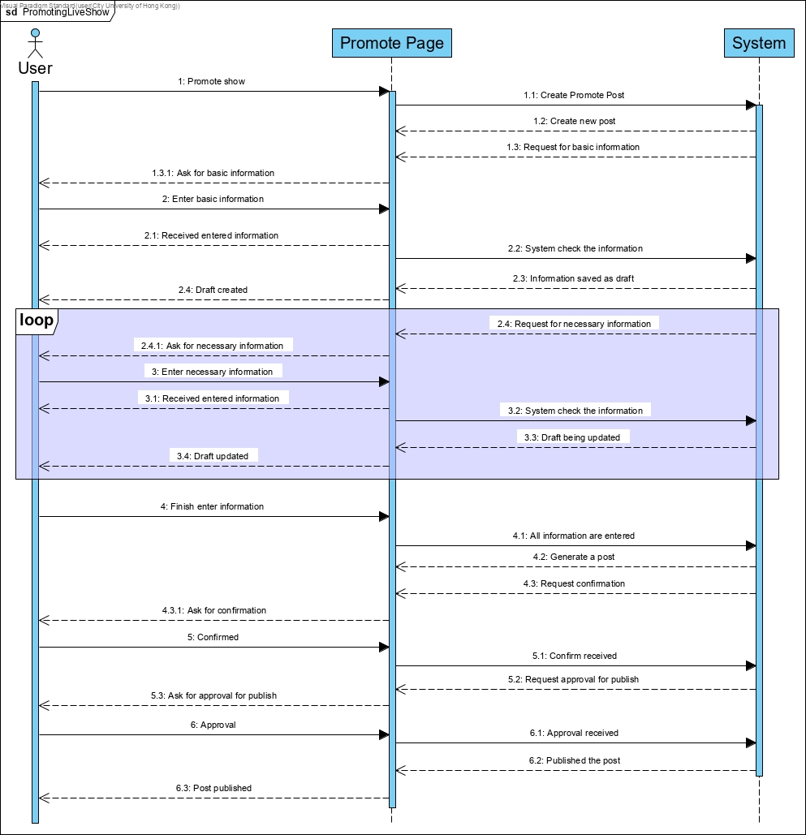

## Principles

Different types of design principles and design patterns are used in the system.

1. OCP

In our class design, the class is able to be modified without affecting the main

function. For the future development, new classes can be easily added to the existing class.

1. ISP

The data in class Stand-up show could be modified through the interface class IShow which allows users to create, show, update and edit.

1. LoD

This can be found in the relationship between class Stand-up show and class

Advertiser. Class Stand-up show can only ask class Advertiser to make

advertisement, rather than directly make advertisement.

## Project Management

In our group, we have one project manager, two assistant project managers and two software designers. In this project, we are focused on software software design and producing a suitable prototype accordingly. The timespan of creating this project is relatively long, therefore, we have to divide the working process into four stages to keep track of our work: 1) Project planning, 1)Software development, 3)Prototype Design and 4)Final work review. We hold a meeting before and after each stage so we can divide work in advance and review our work together before submission. Work reviews are extremely important, we can review each other’s part to ensure everything is in sync, furthermore, to fine tune our work.

## Management Model

In addition to previously mentioned points, there is sufficient time to complete the stages of the project, therefore, we do not have to rush and jump into the next stage abruptly. We have learned to complete all tasks at one stage before moving on to the next stage, as we have adapted the waterfall model in our project management.

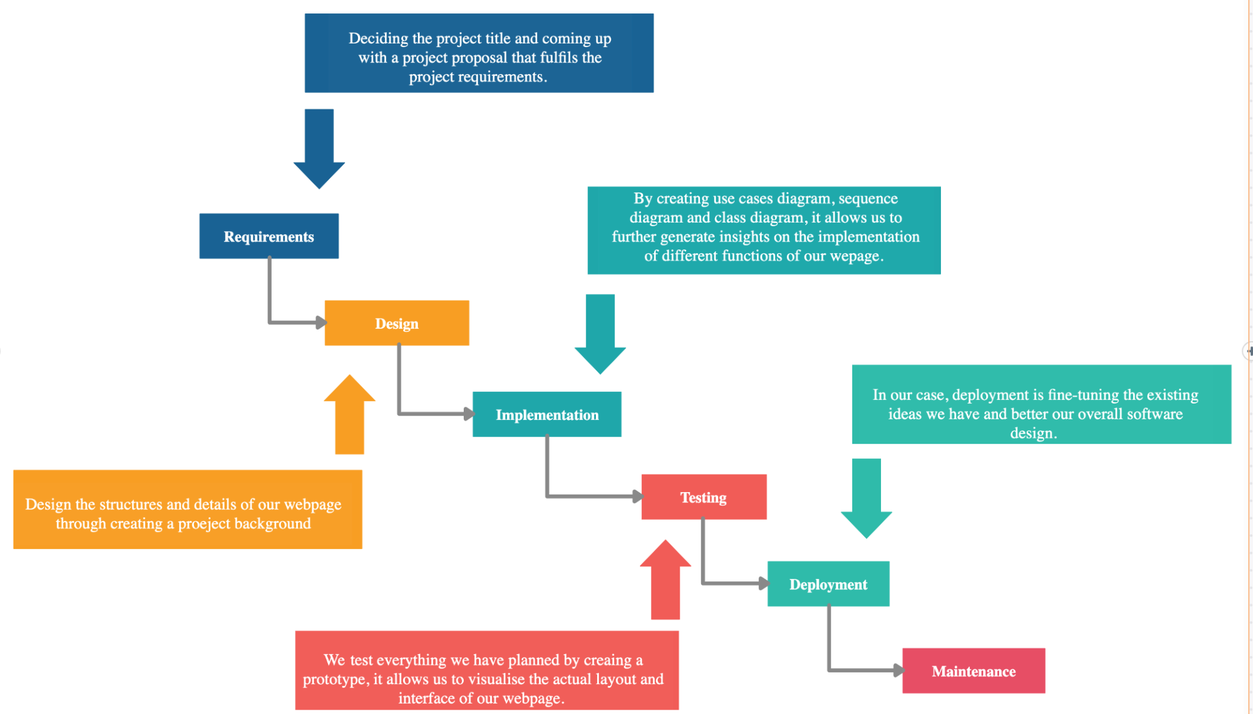

## Risk Management

Maintaining a badly designed and instrumented system is going to be a disaster, as there may be too many unexpected risks and challenges along the way. The better way to deal with this situation is to discover risks in the developing stages of the software design, as a result, risk analysis has been executed regularly. The following are the identified possible risks and their analysis:

## The validity of involved parties

The first potential risk they came to our minds was how can we verify the identities of different parties using our website. For example, whether an organizer is legit and is really doing concrete steps to organize an event, or whether the sponsor of the event is a valid organisation. If we do not deal with such issues, it may affect the professionalism of our webpage, furthermore, legal problems may arise. As to prevent this situation from happening, users are required to upload verifying documents to the website for us to manually identify their identities, which only verified users can be involved in any project. From time to time, some of our webpage administrators would also visit the physical events held by the users through our webpage as quality maintenance.

## Uniqueness of our platform

The uniqueness of our platform is of utmost importance as there are already tons of existing platforms for users to choose from. As a result our webpage must be user-friendly and functionable, which helps us attract and maintain users. Before deciding on the functions of our webpage, it occurred to us that we have to provide something normal platforms cannot provide to users when it comes to organising an event specifically. This is how we have decided to make our platform easily accessible yet professional and safe with the ultimate aim to organise high-level events. As our target users are professionals, it helps us to direct and develop our webpage to cater their needs and concerns. At the end of the day, this makes us stand out from other platforms.

## Security concerns

As our platform involves sponsors, which money transfer is going to happen, we should encourage users to transfer and receive money through our platform. If not a lot of money conflicts may arise, such as sponsors not providing the discussed amount to organisers and performers not receiving their promised salary. Third party services such as Paypal, Visa, Master are going to be our top payment services as they are more secure and accessible to international users. The financial details of organising the events are all recorded on the platform, this allows all parties to keep track of the expenses. We are also planning to introduce a request and approve function in relation to this issue, which means an organiser should request for money with detailed proposals, then the sponsor can choose to approve or not approve the amount. This function can also be used to pay performers, which the sender and receiver of money have all approved and acknowledged the amount being sent or received to avoid future conflicts.

## Functionality of web page

No matter how many test runs were done in advance, all sorts of problems may turn users away. We do not want bugs or imperfections of our web page to provide users with negative experiences. As a result, we always encourage them to report problems on the web page or provide suggestions to improve, while giving them incentives such as free credits that can be used on the web page. From time to time, we will also let customers rate different functions on our web page through surveys, while rewards will also be provided. We hope to direct and improve our web page to be as user-friendly as possible, at the same time, with high customer satisfaction levels.

## Conclusion

The project scope is the core of our project, then we expand our ideas from there onwards. We held meetings before and after each project submission and we suppose this is how working on an actual web page is like, a lot of teamwork and collaborations. The waterfall model has been extremely important to us throughout the project and we have learned that we should do things step by step in order to be well-prepared before the final two stages-deployment and maintenance, cause a not well-written web page is hard to maintain. In our case, after refining the user requirements, scopes and main functions, we drew several diagrams to have a better idea of our design, then finally, create a prototype to visualise our overall design and implementation of different functions.

## Website UI Design

Consistency and Layout

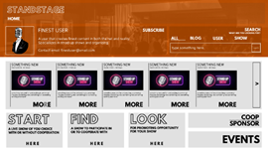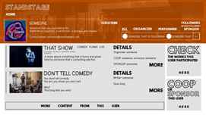

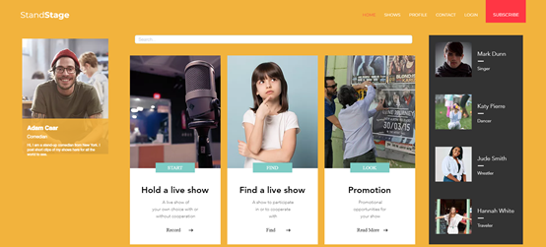

The layout and design of the interface are consistent and follow the same functionality.

For example, Contents that state location is placed on the top (such as the user ID and info are placed on top in the profiles), then followed by shortcuts to the different contents in another page (as they are articles that require an entire page to read comfortably.). Then followed by buttons that provide certain functions.

Such layout allows the page to use most of its size to display abstracts of main content while allowing users to navigate quickly.

The fonts used also follow the consistency. Items that need to be eye-catching use a hollow font, button fonts use a bold font, and the content text uses a less stylish, smoother font to increase readability.

The different size of the fonts also makes navigating the page easier as more important items uses larger font sizes.

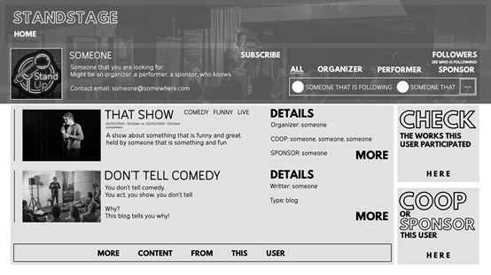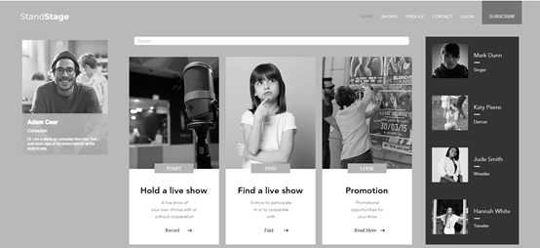

The interface also uses color in different brightness levels to help better differentiate the page. Thus even in black and white the page is quite navigable.